Sistemas Informáticos (Computer Systems)  
First term assessable activity

short line

Authors: Sergi García

Updated October 2023

First term assessable activity

❕ **Attention:** read the whole activity before beginning.

# Introduction

You are one of the best pupils of the Computer Systems subject. You want to use your knowledge to obtain benefit. For that reason, you decide to look for clients and try to sell yours services.

You publish on the Internet an advertisement about your skills in **Fiverr** <https://www.fiverr.com/> and **UpWork** <https://www.upwork.com> and in a few days you find your first customer!

Your first customer is the company **BiCiBiKeR S.L**, a company that manufactures and sells bicycles, as well as hiring them to tourists in several cities in Spain. The company has a main building in “Polígono Vara de Quart” in Valencia.

Your first job is to help them in several tasks related with operating systems and Python scripting. You are nervous, but you have no fear because you are a great professional :)

# Dual install, single install and user creation

Your first job is to configure 2 new computers that have arrived to secretary department. For this purpose, you have to:

1. Make a dual install (Linux + Windows) in a computer.
   1. Remember, first install Windows. You can use VirtualBox to simulate a computer.
   2. We recommend using a lightweight Ubuntu version, like LUbuntu or XUbuntu.
2. Install Linux alone in other computers (You can use Virtual Box).
3. Create two users for each operative system: “foreign_XXX” and “local_XXX”, where XXX is your first surname and your first letter name.
   1. For example, if you are “Rafa Nadal”, users will be “foreign_nadalr” and “local_nadalr”

# Linux maintenance

In the machine with Linux, you have to do several maintenances tasks:

1. Update LibreOffice version to the last, using a PPA and apt commands. More information in <https://vivaelsoftwarelibre.com/repositorio-ppa-de-libreoffice/>
2. Create directory structure inside “/home/local_XXX” like is shown in this figure. You should create it using console commands (no GUI allowed):

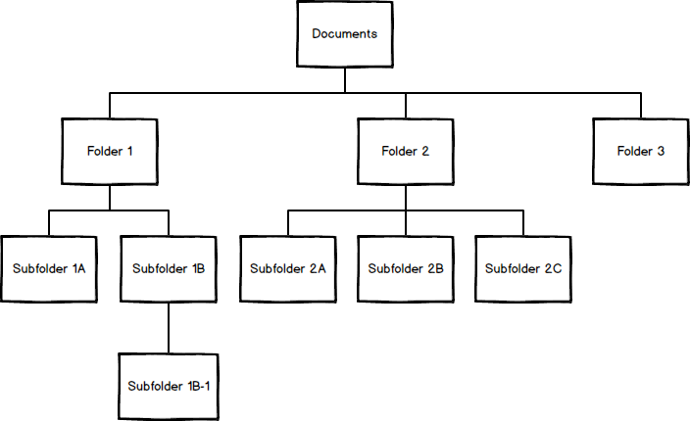

# Docker

Also, you have to install Docker in one machine using Linux. When you have Docker installed, you have to create a Linux Container following these steps:

* Create a new container using as base image <https://hub.docker.com/_/ubuntu> or other Linux docker image that you like.
* Create two users inside Docker container. Users should be called “fdocker_XXX” and “ldocker_XXX”, where XXX is your first surname and your first letter name.
  + For example, if you are “Rafa Nadal”, users will be “fdocker_nadalr” and “ldocker_nadalr”.
* Upload your container as a custom image to <https://hub.docker.com> and share it with us. We will assess this part downloading your image from Docker Hub.

# Creating a Python 3 script

We have to create a Python 3 script to show our bike prices depending on model and discount.

Our bikes are available in three colours: White, Red and Black. White model costs 250€, Red model costs 280€ and Black model costs 300€.

We want to create a program that should ask for the model name (it hasn’t to be case-sensitive).

* If the model is wrong, you have to print an error message.
* If the model is right, our program should ask for a “Discount Code”.
* If the user writes INENGLISHPLEASE, our program should print model price and, in green, the model price with 5% discount (it should be calculated inside the program!).
* If Discount Code is wrong, our program should print model price without any variation.

**This script should be FULL COMMENTED (with a comment on each line).**

# Delivery

**All this assessable activity has to be written in English.**

❕ **Attention:** English Assessable Task 3 obtains its mark from the use of English in this activity.

You can send the task until **Monday 4th December 2023 at 23:55.**

**You have to deliver:**

* A document explaining:
  + Explain how have you done a Dual installation.
    - You don’t need to use captures, simply explain process.
  + Explain how you have created users in each operating systems.
    - You don’t need to use captures, simply explain process.
  + Show captures proving that dual installation has been done and that each operating system has required users.
  + Explain how you have updated LibreOffice to last version via PPA and prove it with a capture of LibreOffice version installed.
  + Write and explains commands used to create directory structure and navigate between them.
  + Show a screen capture to prove directory structure has been created in your user.
  + The URL of Docker Hub where we can download your Docker image, in order to test if it is right.
    - If your image is private, you can share it to user “sergarb1” from Docker Hub.
* A Python file with the required script fully commented.

# Assessment

❕ **Attention:** English Assessable Task 3 obtains its mark from the use of English in this activity.

The activity is individual and non-transferable. To consider it completed, it is not enough just to deliver the dossier. **The student must be able to defend his/her exercise at the request of the teacher and be able to make small modifications related to it, in order to demonstrate the acquisition of knowledge and avoid any suspicion of copying.**

📖 **Important:** you should do this activity by yourself. Using tools like ChatGPT, Deepl, Google Translate or help from a human person is punished as copy with every consequence (fail of the complete module).

**The copy is punished with the fail of the complete module.**

**Evaluation is done in a global way and takes into account elements such as:**

* Correction in the explanations.
* Correct operation of the script.
* Nice visual presentation of documents.
* A right structure in the generated documents:
  + Front page.
  + Index.
  + Page break
  + Styles on the page
  + Numeration
  + Header and footer

# Recommendations

The assessable activity is designed in order to put into practice the theoretical knowledge. The main objective is to face the practical problem in order to improve your knowledge.

The fundamental objectives are:

* Install two different operating systems and be able to boot each one.
* Create and manage users.
* Use Linux console commands.
* Install Docker.
* Create Docker containers, operate inside them, and upload containers as Docker Images.
* Improve your skills programming Python.
* Improve your English skills, specially with technical vocabulary.